Table of Contents

What are GLAMTASTIC Affirmations? 10
Positive Affirmation 10
Best Positive Affirmations. 12
- Affirmations Allow You to Experience New Possibilities13
- Affirmations Empower You to Create a Positive Mindset13
- Affirmations Are Totally Flexible and Creative 14
Advantages of Affirmation 16
Affirmations of Gratitude 20
Advertisement 22
Emotions 23
GLAMTASTIC Affirmation 27
Eating & Health 30
Financial 32
Get it Done Now!!! Stop Procrastination 34
Motivation 37
Wealth 39
Love 41
MY GLAMTASTIC favorite Affirmations… 44
My Personal Affirmations 58
My Spiritual Affirmations 59
1

My Career/Business Affirmations 60
My Love Affirmations 61
My Family Affirmations 62
My Health/Body Affirmations 63
My Mental Health Affirmations 64
My Financial Affirmations 65
My Affirmations for Friends & Social Circle 66
My Travel Affirmations 67
My Other Affirmations 68

2

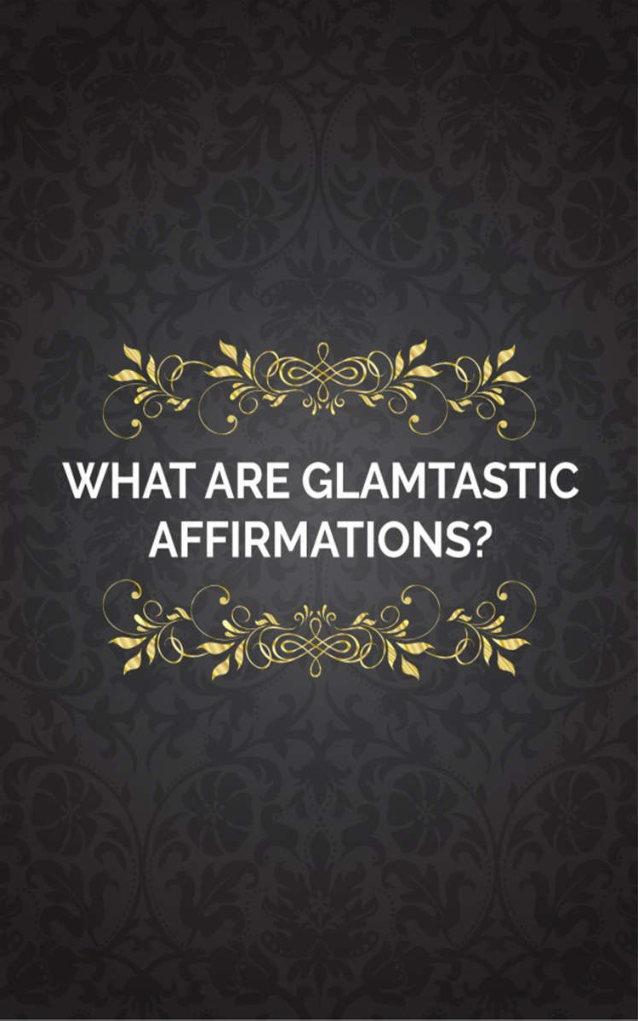
GLAMTASTIC Affirmation

3

4

What are GLAMTASTIC
Affirmations?

Power of Affirmation is really anything you say or think. All too often, what we say and think is quite negative and doesn’t create good experiences for us. We have to retrain our thinking and speaking into positive patterns if we want to change our lives.

An affirmation opens the door. It is a beginning point on the path to change. In essence, you’re saying to your subconscious mind: “I am taking responsibility. I am aware that there is something I can do to change.” When I speak of affirmations, I am focusing on consciously choosing words that will either help eliminate something from my life, or help create something new in my life.

Every thought you think and every word you speak is an affirmation. All of our self-talk and our internal dialogue is a stream of affirmations. You’re using affirmations every moment whether you know it or not. You’re affirming and creating

5

your life experiences with every word and thought.

Your beliefs are merely habitual thinking patterns that you learned as a child. Many of them work very well for you. Other beliefs may be limiting your ability to create the very things you say you want. What you want and what you believe you deserve may be very different. You need to pay attention to your thoughts so that you can begin to eliminate the ones creating experiences you do not want in your life.

Please realize that every complaint is an affirmation of something you think you don’t want in your life. Every time you get angry, you’re affirming that you want more anger in your life. Every time you feel like a victim, you’re affirming that you want to continue to be a victim. If you feel that Life isn’t giving you what you want in your world, then it’s certain that you will never see all of the good things that life has to offer you; that is, until you change the way you think and speak.

You are not a bad person for thinking the way you do. You’ve just never learned how to think and speak in a positive mindset that is conducive for change. People throughout the world are just

6

now beginning to learn that our thoughts create our experiences. Your parents probably didn’t know this, so they couldn’t possibly teach it to you. They taught you how to look at life in the way that their parents taught them. So nobody is wrong. However, it’s time for all of us to wake up and begin to consciously create our lives in a way that pleases and supports us. You can do it. I can do it. We all can do it; we just need to learn how. So let’s get to it.

Sometimes people will say their affirmations once a day and complain the rest of the time. It will take a long time for affirmations to work if they’re done that way. The complaining affirmations will always win. Why? Because the majority normally rules, and in this case your negative statements that are said on a continuous basis (likely with great passion) will outweigh the few positive affirmations you are trying to ignite.

However, saying affirmations is only part of the process. What you choose to do throughout the rest of the day is even more important. The secret to having your affirmations work quickly and consistently is to prepare an atmosphere for them to grow. Affirmations are like seeds planted in soil. Poor soil, poor growth; rich soil, abundant

7

growth. The more you choose to think thoughts that make you feel good, the quicker the affirmations work.

So think happy thoughts. It’s that simple and it is doable. The way you choose to think, right now, is a choice. You may not realize it because you’ve thought this way for so long, but it really is a choice. Now . . . today . . . this moment . . . you can choose to change your thinking. Your life won’t turn around overnight, but if you’re consistent and make the choice on a daily basis to think thoughts that make you feel good, you’ll definitely make positive changes in every area of
your life.

8

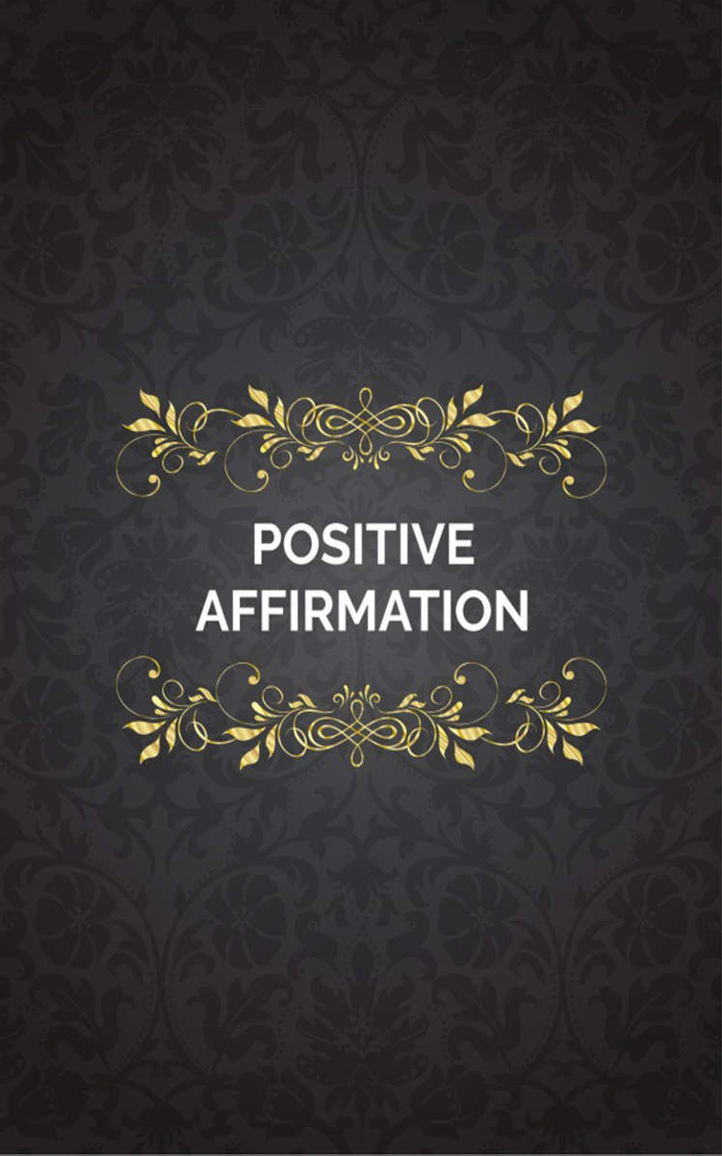
GLAMTASTIC Affirmation

9

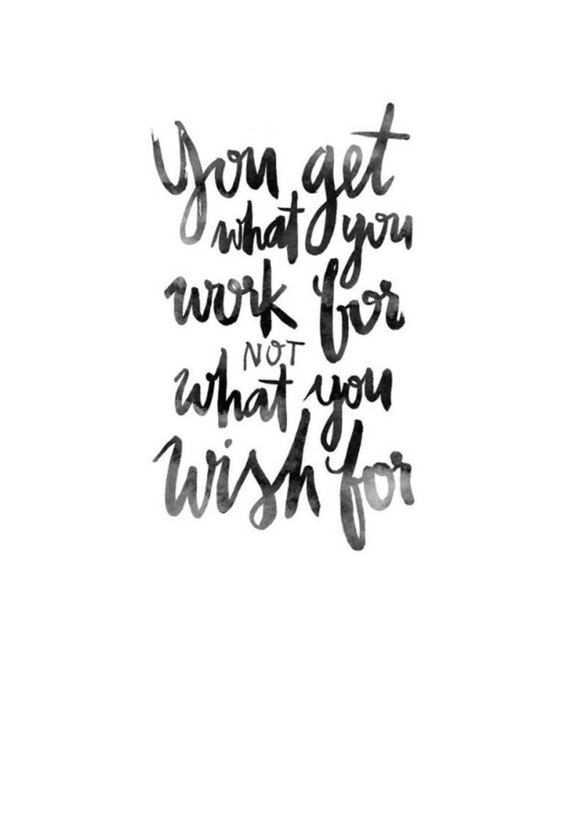
10

Positive Affirmation

Positive affirmations address something in our lives that we want to adjust or replace with something better: change an overweight body into a slim and fit one, or replace an unhealthy daily habit like smoking with a healthy daily habit of drinking more water. The reason we feel better when speaking these positive thoughts as verbal statements is because the positive energy of good thoughts and pictures in our mind raises our vibration frequency and causes chemical changes in our body that tell us we're happy.

11

Best Positive Affirmations.

Keeping God first and learning to speak life over your circumstances are the best things in the world. I personally do not believe in doing affirmations as the law of attraction, but I do believing in having faith and believing that with God all things are possible to those that believe. I believe if we can get a vision then speak it, water it with prayer, faith, and a little work, we will possess the promise land that God desires for us to have. It is God’s desire that we prosper and be in good health. He wants us to have abundance and live in overflow.

Working with affirmations is an empowering experience.

Whether you’re using some awesome readymade affirmations or you’ve created your own perfect personal affirmation, the act of consciously choosing and using a new thought pattern places you further ahead of the usual automatic human thought process. These are three benefits of equipping your life with positive
affirmations:

12

Affirmations Allow You to Experience New Possibilities

When you start using a new affirmation, the statement may seem untrue for you. This is a
good thing, as the point of an affirmation is to open you up to a new way of thinking. This new way of thinking won’t be automatic for you yet, but thinking about the possibility of it being true will open you up to new possibilities in your life that you were completely closed to before.

Affirmations Empower You to Create a Positive Mindset

Using affirmations are so GLAMTASTIC and empowering! You choose what you want to think, you decide how quickly you can have your faith strengthened with this new belief, and you decide exactly what you’re doing it for and why. No one else needs to be involved except you and God, and taking on an affirmation is as simple as the reminders you set in place to support you in the process. Use sticky notes around your home and in your car. Use your phone reminder to beep a few times throughout the day. Stick a note in your wallet so it’s in your face whenever you reach for your debit card.

13

You have the power to change your beliefs: God gave it to you, so use it now. You decide when, how, where & what.

Affirmations Are Totally Flexible and Creative
God made us super computers, so we can program ourselves to learn whatever we put our minds to! Whatever the situation in life: money, friends, health or happiness, we can create an affirmation that will suit your situation perfectly and move you from where you are to where you
want to be.

14

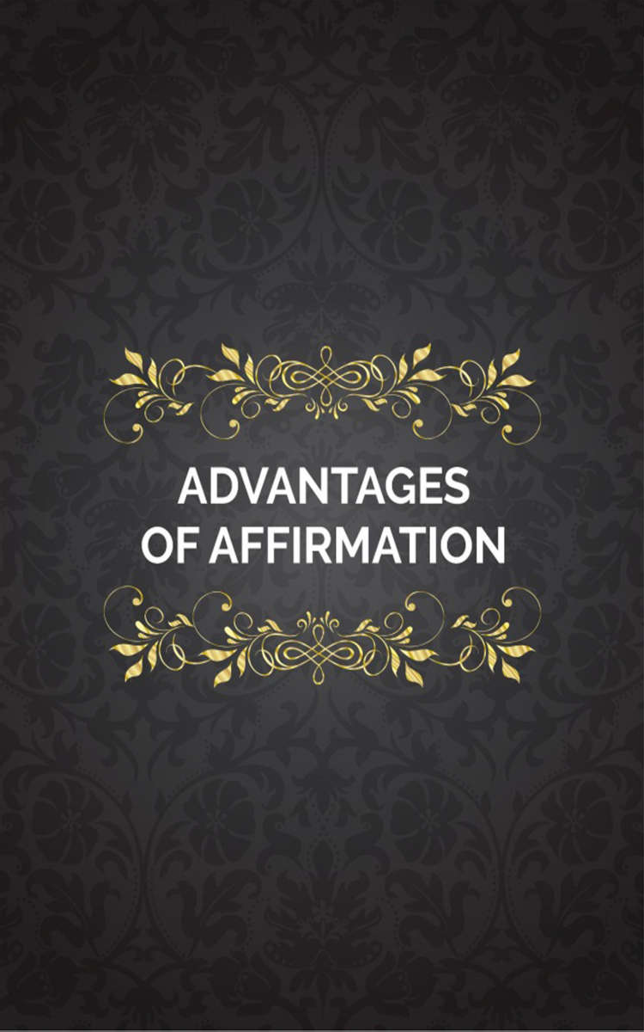
GLAMTASTIC Affirmation

15

16

Advantages of Affirmation

Affirmations are not only for bringing a specific goal into existence. They are meant to encompass a life filled with positivity and gratitude.

While they do help you achieve certain goals, there’s more to them than that. Let’s say you speak it and get the job you wanted. Now what? Do you drop the “I am the boss” affirmation? Not exactly, because you might have a business on the side or desire your own business still: In this case no you don’t. If you are satisfied with just having the new job and that’s enough then yes, you do drop that one, but you should replace it with a new affirmation. Something like, “I love my job,” or “I enjoy learning new things every day.” The affirmation plan never ends; it constantly updates, becoming something that you are constantly practicing and making a part of your life.

17

These are a few of the Affirmation tips:

  - You become aware of your daily thoughts and words, reducing the risk of letting negativity seep in.
  - You notice more synchronicities in your life, which serves to encourage and motivate you to keep up the practice.
  - Daily affirmations not only help keep you surrounded by the things you want in your life, but they help bring about more blessings and gifts.
  - A daily practice helps to keep the small things in perspective. In this high-speed world you can easily lose sight of how large the small things really are. When you're healthy you may forget to think about how much you appreciate it. A simple morning affirmation sentence of “I thank God that I am healthy” can go a long way.
  - A recent study shows that optimistic people have healthier hearts, and affirmations help you to stay positive.
  - As you continue this practice, others will take note and you will begin to help those around you without even trying. This, in turn, helps keep you focused.
  - Daily affirmations keep you in a constant state
of gratitude.

18

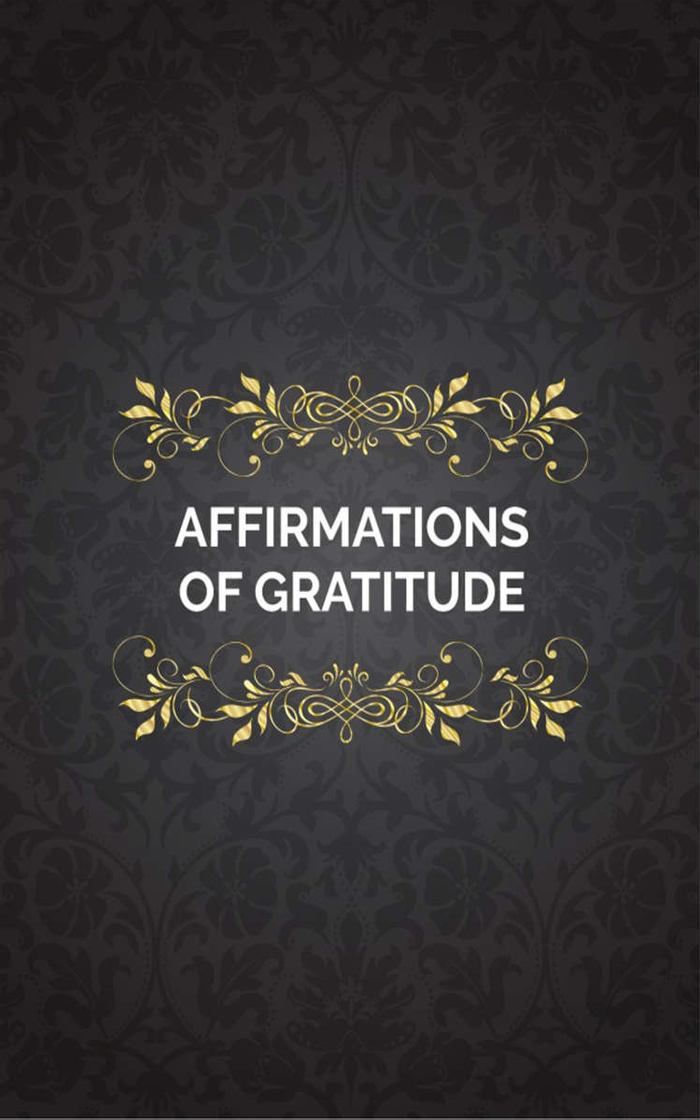
GLAMTASTIC Affirmation

19

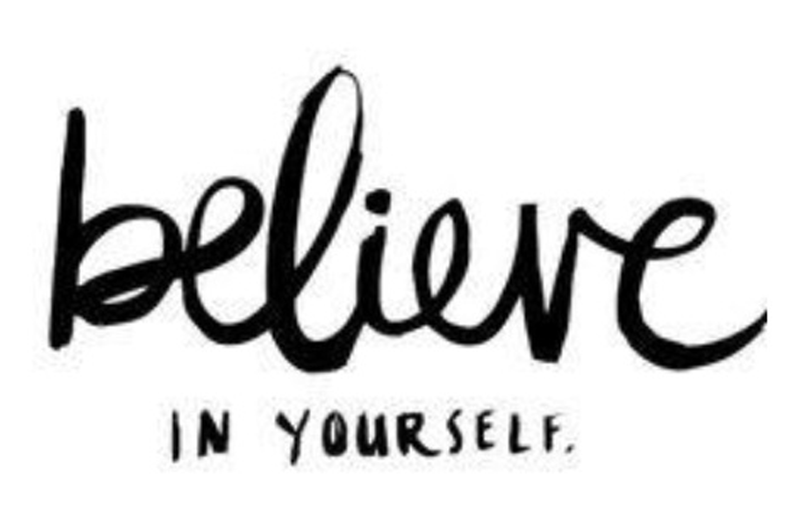

20

Affirmations of Gratitude

Gratitude helps you stay positive and should be practiced daily.

The problem is that gratitude for certain things can morph over time. For example, you got that great job after scoping it out for months, interviewing five times, and purchasing a new wardrobe to fit the title. At first you were ecstatic, jumping up and down and calling everyone you knew to tell them what you manifested. Fast forward two years. The hours are long, you haven’t received a raise, and your boss blames you for things that have nothing to do with you. By now your level of gratitude for this job is different. Perhaps you’re even trying to manifest a new job and have dropped your affirmations of gratitude for this one.

Try this approach instead: Continue with your affirmations of being very thankful for your position and what it provides. The negatives are still there, but using the affirmations to help you focus on the positive aspects will give more power to the other set of affirmations in your practice. Affirmations for who you are or who

21

you are aspiring to become, are important but should not hold more weight than the affirmations of gratitude for what you’ve already
received.

Advertisement

There are numerous reasons why you may not have achieved lasting change from using positive affirmations. Here, I'll address the major reasons and give you a step-by-step process to have greater success with them. There is a missing piece to most instructions for affirmations. Without this piece to the puzzle, most people who use them for lasting change wind up feeling frustrated that they failed. If you are one of the millions of people who have used this process without the results you were looking
for, you're not alone.

22

Emotions

Emotions are the most powerful energy for creation. Both positive and negative feelings towards things you want and things you don't want shape your atmosphere. You can speak verbal affirmations until you're blue in the face, but if you're unable to feel what it's like to have what you want, you won't get it. You may be asking, "How will I know how it feels if I don't have it yet?" Great question! Use your imagination.

The subconscious mind doesn't know the difference between what is real and what is imagined. This is why people can tell us we're awful when we know we rock; if they tell us often enough, we will begin to doubt ourselves and believe them (a great reason to delete negative people from your life).

If you've been blessed enough to have experienced what you want (great relationship, your ideal job, etc.) you can recall the feelings of happiness they gave you. Remember these moments vividly. If God did it before, He can do

23

it again. Say your “I AM” statements and speak your positive affirmations aloud.

If you haven't yet experienced the things you want, recall a time when you felt happy, excited,
or fulfilled, and hold on to this memory.

24

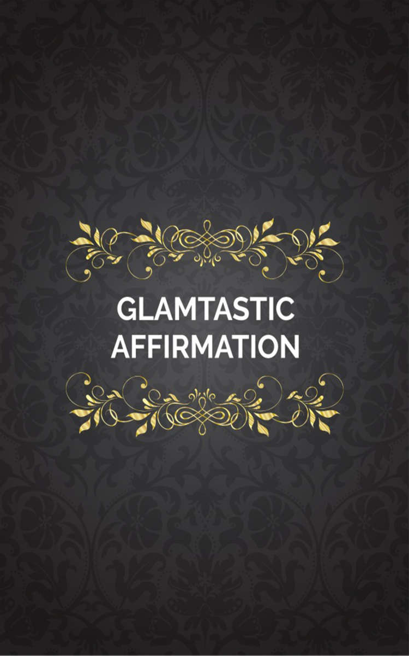
GLAMTASTIC Affirmation

25

26

GLAMTASTIC
Affirmation

Let Your Words Transform Your Life Speak it until you see results…

So you are saying, “GLAM Coach, what is The Power of Affirmations?” They are positive statements that describe a desired situation or goal, and are often repeated until they get impressed on the subconscious mind. This process causes the subconscious mind to strive and to work on your behalf in order to make the positive statement come true. Affirmations are declarations of what you wish to be.

The power of speaking positively over your life and circumstances can bring real results. When your mind lines up with your words, it becomes a very powerful tool, almost like a funnel. Your words may seem small when they come out of your mouth, but they grow larger and larger when they impact your life. The way we see and interpret our lives and the lives of others have a great impact on what we say. It is easy to say something negative in bad situations and

27

something good in positive ones. We call it “keeping it real”. The truth is, it is real if that’s how you view it. We’ve all heard it before. You
can view a glass of water half empty or half full.
That means even though the measurements are the same, the views of two different people could be obviously different. One might drink it and be full, and the other might still be thirsty all because of their perspective of the amounts in the glass. To live a GLAMTASTIC life you have to work what you have until God opens up those flood gates for more. “It will work if you work it” is one of the truest statements ever. It applies in all aspects of our lives. It applies to the Body, Mind, Spirit/Soul, and Style. You don’t have to be a rocket scientist. You just have to be a willing vessel for His will. Once your mind is aligned with your positive words, the sky is the limit.

Self-improvement isn’t a big mystery. It is not some kind of magic. It doesn’t have to be so complicated and there is no secret underground system. Simply stated, it is one of the quickest personal development practices that can be utilized.

Below you will find a few examples of affirmations. Please feel free to make up your own affirmations to fit your needs. I recommend

28

that you write it out, or type it out and print it on exquisite paper. Frame it or get it laminated. Put it in a place where you can see it daily. Make a copy for work and put in on the wall, or at your desk.

29

Eating & Health
I am losing weight now I am not a glutton
I am slim and fit

I always take care of my body I only eat healthy food
I am motivated to lose weight and become healthy

I am living a healthy life style

I am dedicated to following my weight loss plan I am disciplined in my eating habits
I am strong in mind and body

I am completely focused on losing weight I am a fat burning machine
Living a healthy lifestyle is becoming easier

I am transforming into someone who exercises regularly

30

Others are starting to notice I’m losing weight

I find it easier to eat right and take care of myself I will always choose healthy foods over junk
I am more disciplined with each day that passes I will always respect and take care of my body
I find it easy to lose weight I enjoy exercising
I lose weight and keep it off

I am slim, healthy, and happy

I think positively and just naturally lose weight I find it easy to stay in shape
I love eating healthy food and nurturing my body

I eat healthy and set a good example for my family

31

Financial
I am never in Debt

I am never ever broke

I make at least 6 figures yearly

I make at least a million dollars a year I am a millionaire
I am a billionaire

My mind is highly focused on making large sums of money

I believe in myself completely

I am highly motivated and productive

I am highly blessed and I have favor with God I always work hard
The windows of heaven are open and God is pouring out blessings on me & my family

I am certain that I am successful

32

I am motivated and persistent when going for my goals

I work hard and push through negativity and criticism

I will keep pushing until I achieve massive success

My mind is totally focused Money is finding me now
I will keep moving forward no matter how many obstacles I encounter

I am transformed by the renewing of my mind

I will always think positively when I fail, and keep trying no matter what.

33

Get it Done Now!!! Stop Procrastination
I act now

I am a doer

I take charge and get things done

I am always moving forward and working on my goals

I work hard first and play later

I always start a project right away

I always get a head start and have plenty of time to complete my work

Others admire that I make things happen now rather than later

I complete projects with plenty of time to spare

I am someone who seizes the moment and takes action

I am a proactive person I do not procrastinate

34

I always take action

It is easy to begin large projects & finish them

I will always get started right away, even if I don’t feel like it

I am more productive with each passing moment I effortlessly get things done
I take charge of my time and achieve my goals Taking immediate action is a part of who I am I choose work over procrastination
I love the feeling of getting a head start. It’s normal for me to start projects early

I take action and get things done

Making the best use of my time comes easy to me

I’m the kind of person who always dives straight into my work

I enjoy starting quickly and getting the job done Making things happen is just what I do

35

Others can rely on me because I always follow through

I enjoy working hard and getting things done

36

Motivation
I am a highly motivated person I am motivated at all times
I am always motivated and always get things done on time

I am a naturally motivated individual and motivation comes naturally to me

I am motivated and energized at the beginning of every day

I am highly motivated, ambitious and driven

I find it easy to motivate myself and get myself in the right state of mind

I am always looked up to as someone with high energy, drive, and motivation

I stay motivated throughout a project no matter what

I am always motivated and my positive energy motivates and lifts those around me

The motivation comes quickly when I need it

37

I am more and more driven and ambitious and complete my Kingdom assignments

I will be highly motivated and productive

I am motivated in all areas of my life so that my Kingdom assignments will be complete

Each day I am more and more motivated

Every day I wake up refreshed, ready to go, and full of motivation

Being motivated and ambitious is a part of life I enjoy

I am always in the right state of mind and motivated
Feeling motivated, energized and on fire to finish strong is normal for me

38

Wealth
I am wealthy

I always have money

I have financial abundance

I always think positively about money I have many financial opportunities
God always shows me a way to make large profits

I am rich and prosperous My life is full of abundance
I am focused & achieving wealth My bank account is always growing Money will be flowing into my life
Financial opportunities always come my way I am financially successful
My bank account never seems to stop growing

39

I have a money mindset

Money just always seems to come my way

I have an abundance of money and material abundance

I always get Instant Upgrades

I eat at 5 Diamond Restaurants I stay at 5 Diamond Hotels
I make Kingdom connections

I have global connections that pay well for my services

My calendar is full yearly from now on for paid events for my services

People are seeking me out now to pay for my goods and services

People are seeking me now for my wisdom that God gave me

I finish & complete everything I start

40

Love
I love myself unconditionally

I am a good person who deserves to be happy I take pride in who I am
I am happy just being me

I am totally comfortable being myself

I have limitless confidence in my abilities I accept myself deeply and completely
I accomplish great things now

Others are inspired by my ability to be myself

I have confidence in my ability to do whatever I set my mind to

I go after my goals and do what makes me happy

I know I have the right to be happy and nothing can take that away from me

I truly love myself and this helps others to accept me for who I am

41

I notice all the positive things in my life I am loved by God and people
I am successful I am Beautiful
I am Grateful I am Great
I am a Leader

I am Productive I am a Winner
I am an Overcomer I am Limitless
I am GLAMTASTIC

I am Disciplined

I Am Focused

I am Organized I am Debt Free
I am a Lender & not a Borrower

42

I am Confident I am Talented I am Blessed
I am Favored I am Caring

43

MY GLAMTASTIC favorite Affirmations…
I am Dependable

I am a Child of God

I am God’s Favored Child I am Wealthy
I am a giver

I am a Prayer I am a Tither
I am Energetic I am Lovable
I have the Fullness of JOY

I will Worship the Lord with exceeding great joy

I pursue Righteousness and love, therefore I find prosperity & honor are mines. (Proverbs 21:21)

I am Humble. (2 Chronicles 12:6)
I have Godliness (1Timothy 6:11)
44

I am Reverent

I am Holy Ghost Filled

I have all the fruit of the Spirit

My whole family is covered by The Blood of Jesus & Saved Hebrews (10:3-14)

God has not given me the Spirit of fear but of power, love, self-control, and a sound mind. (2 Timothy 1:7)

I am Merciful (Matthew 5:7)

My Heart is Pure (Matthew 5:8)

I am A Peace Maker (Matthew 5:9)
I am Meek (Matthew 5:5)
I seek God’s Kingdom and His righteousness; I know all good things are added to me. (Matthew 6:33)

I walk in love

I have a Clean Heart (Proverbs 21:2) I have moral excellence

45

I am God Fearing

I have a Gentle Tongue (Proverbs 15:1-4)

I am protected from the enemy (Psalms 91:4 & Isaiah 54:17)

I have unconditional love (Matthew 5:44)
I am Friendly
I am an Encourager

I am slow to anger (James 1:19)

I am quick to forgive (Colossians 3:13-14)

I am healed by Faith & by JESUS’ stripes. (Mark 10:53 & 1 Peter 2:24)

I will always Prosper & be in good health (3 John 1:2)

I am Strong

I am Forgiven (Ephesians 1:7)
I am praying more
I am reading & studying more of my bible (2 Timothy 2:15)

46

My Heart is healed from Brokenness (Psalms 147:3)

I keep myself under subjection

I have Self-Control in every area of my life (1 Corinthians 9:25 /Titus 2:2)

I am sober minded (Titus 2:2-6)
I am patient
I have much wisdom

I use all my spiritual gifts

I use all my natural gifts and talents to the fullest I am Royalty (1 Peter 2:9)
I know that everything is possible because I Believe. (Mark 9:23)

I am long suffering

I am obedient to God

I stay in the perfect will of God I am temperate in all things
I am Wise

47

I am watchful I am vigilant
I am Careful

I am mindful of others

I walk in Kingdom integrity I am unselfish
I am zealous

I keep all 10 Commandments I am an Active Intercessor
I am always In Constant Prayer without ceasing I am an Active Prayer Warrior
I am a great leader in the land

I will Heal the sick, raise the dead, cleanse those who have leprosy (diseased), drive out demons, freely I have received; freely I give. (Mathew 10:8)
I possess my promise land now (Joshua 1:24 & Numbers 33:53)

48

All Moneys owed to me and my family lineage is released & coming into my accounts & wallets now

I keep on the whole Armor of God I am Victorious
I am uplifting to others

I hear God’s voice clearly & a stranger I will now follow

I see Amazing Miracles all the time

I have a very successful Ministry
I have a very successful Global Ministry
All my events I have or host will be Sold Out

All products that my business has to sell will be in high demand and sell out quickly

I Have a Systematic plan with structure & order in every area of my life

All Settlements & Child support are released now & in my account

49

All my student loans are paid off now & never to be seen again

I keep big clear thoughts, dreams, & visions

I have a success mindset I am ambitious
I have bold goals that are reached

I will make it to Heaven after my assignment is complete in the earth

I take action now to achieve my goals I am accountable
I am never jealous

I am always in the right place at the right time with the right people

I am articulate in my speech I am prepared at all times
I am fearless I am creative I learn easily
50

I am helpful I am fair
I am considerate I am gentle
I am polite I am sweet I am kind
I am truthful

I am a supportive person

I am forgiving Proverbs (17:9)
I have a winning smile
I make wise choices every time

I accept all the right opportunities I am Confident
I think before I speak I am powerful

51

I am Passionate about Life I have a successful Career
I have a very successful Business

I have a very successful Global Business I am never in financial trouble
I am never in any trouble I Set Goals & Finish them I am Sold Out
I have conversations that matter I run with Go Getters
I have only positive circles of influence When I speak the world listens
I have meetings & conversations that yield big increase & results

I never complain

I am a global world changer I am calm and powerful

52

I am speedy and orderly

I have Kingdom Set values I am on time, every time
I have great organized time management My mind is Alert
I am always in my right mind

I write #1 New York Times & Barns & Nobel bester sellers every time (Flying off the shelves)

I am never ever broke

I always live in overflow and abundance
I make a 6 Figure income yearly
I make over $500,000 a year

I make over a Million Dollars a year I am a Millionaire
I always pay all my bills & my business bills on time

I have my own personal Full time Maid

53

I have my own Personal Full Time Cook

I have my own personal Full Time Makeup Artist I have my own personal fashion stylist
I have my own personal assistant I have a personal secretary
I own a building for my business

I own my own Building for my business or businesses

I have the money to outsource my business and save time

I have already finished my business branding I am a National Public Speaker or Consultant I am a global public Speaker or Consultant
I keep my business updated I dress well daily
I live a luxury lifestyle I own a Yacht

54

I own my Plane

I own my Homes

I treat everyone with respect I help the needy
I Get grants & scholarships funded to me now I love to do volunteer work
God is my Provider I am a Nurturer
I am Affectionate

I am Compassionate

I have Great Communication Skills

I have Great and meaningful Conversations I bring Laughter into every room I enter
I have a God fearing husband that loves his own wife like Christ loves the church (for married people)

I am a submissive wife to my own husband or vice versa

55

I am a Good Listener

My marriage is in sync & we are on 1 Accord

I love & Keep no record of wrong (1Corinthians 13:5)

I receive 5 Star treatment everywhere I go I always get Instant Upgrades
I eat at 5 Diamond Restaurants
I stay at 5 Diamond Hotels
I make Kingdom connections

I have global connections that pay well for my services

My calendar is full yearly from now on for paid events for my services

People are seeking me out now to pay for my goods and services

People are seeking me now for my wisdom that God gave me

I finish & complete everything I start

56

“I am loved by God and people”
I can do all things through Christ that strengthens me…

This is my personal belief about affirmations. I believe that if you put Christ first all of the rest will line up. I also put scripture references in some of the affirmations. At the beginning of affirmations Christ is first for me. These will work if you work them.

Make sure to write out your own
GLAMTASTIC Affirmations.
Each person is different and has different needs and desires. GLAMSQUAD let’s start redesigning our self-talk today. Get to work. I am pushing you forward into destiny.

XOXO Love You, #The GLAM Coach
GLAM= Grace, Love, and Mercy

57

My Personal Affirmations

58

My Spiritual Affirmations

59

My Career/Business Affirmations

60

My Love Affirmations

61

My Family Affirmations

62

My Health/Body Affirmations

63

My Mental Health Affirmations

64

My Financial Affirmations

65

My Affirmations for Friends & Social Circle

66

My Travel Affirmations

67

My Other Affirmations

68

